**HOMEWORK OUTLINE**

1. Read over the information on relative pronouns/clauses.
2. Take the [relative pronoun quiz](https://forms.office.com/Pages/ResponsePage.aspx?id=_cbR8PDfakiOkc_v78fZjewxvTkohuBBuIf3U9gaXw9URDVCNzZBUDFNMVU1Q0hFR1dMNzEwNjBXRi4u). [TEACHERS CREATE LINK FOR YOUR CLASS]
3. Read over the 4 reviews of short films. Notice the the use of relative pronouns/clauses in red. Look up any words you do not know. Specifically look up words underlines in black.
4. Think about the common elements in all 4 movie reviews. Which parts of the movie are mentioned?
5. Watch the short film [Le Miroir.](http://v.youku.com/v_show/id_XNjI0NzE2MjMy.html?spm=a2h0k.8191407.0.0&from=s1.8-1-1.2) If the link does not work, you can find it on Youku.
6. Write your own short film review of Le Miroir. Bring your typed review to the next writing class.



**Le Miroir**

**RELATIVE CLAUSES**

(Source: [British Council LearnEnglish](https://learnenglish.britishcouncil.org/en/english-grammar/clause-phrase-and-sentence/verb-patterns/relative-clauses))

**1. The relative pronouns:**

The [relative pronouns](https://learnenglish.britishcouncil.org/node/1295/) are:

|  |  |  |
| --- | --- | --- |
| SUBJECT | OBJECT | POSSESSIVE |
| who | whom | whose |
| which | which | whose |
| that | that |  |

We use ***who***and ***whom***for people, and ***which***or ***that*** for things.

We use [relative pronouns](https://learnenglish.britishcouncil.org/node/1295/) to introduce relative clauses, which tell us more about people and things.

**2. Relative clauses to postmodify a noun**

We use relative clauses to postmodify a noun - to **make clear**which person or thing we are talking about. In these clauses we can have the relative pronoun ***who***, ***which***, ***whose***or ***that***

* as **subject:**

Isn’t that **the woman who lives**across the road from you?  
The police said **the accident that happened**last night was unavoidable  
The newspaper reported that **the tiger which killed**its keeper has been put down.

**WARNING**:  
The **relative pronoun**is the **subject**of the clause.  
We do **not repeat**the subject:

*The woman **who ~~[she]~~ lives**across the road…  
*The tiger **which ~~[it]~~ killed**its keeper …

* as **object**of a clause:

Have you seen **those people whom** **we met**on holiday?  
You shouldn’t believe **everything that you read** in the newspaper.  
The **house that we rented** in London was fully furnished.  
The food was definitely the **thing which I enjoyed most** about our holiday.

- When the relative pronoun is the **object**of its clause we sometimes **leave it out**:

Have you seen those **people we**met on holiday?  
You shouldn’t believe **everything you**read in the newspaper.  
The **house we**rented in London was fully furnished.  
The food was definitely the **thing I** enjoyed most about our holiday.

**WARNING**:  
The **relative pronoun**is the **object**of the clause.  
We do **not repeat**the object:

Have you seen those people who we met **~~[them]~~** on holiday?  
The house that we rented **~~[it]~~** in London was fully furnished.  
The food was definitely the thing I enjoyed **~~[it]~~** most about our holiday.

**3. Times and places**

We also use ***when***with times and ***where***with places to make it clear **which**time or place we are talking about:

England won the world cup in 1996. It was **the year when**we got married.  
I remember my twentieth birthday. It was **the day when**the tsunami happened.  
Do you remember **the place where**we caught the train?  
Stratford-upon-Avon is **the town where**Shakespeare was born.

... but we can leave out the word when:

England won the world cup in 1996. It was the **year we**got married.  
I remember my twentieth birthday. It was the **day the tsunami** happened.

**4. Giving additional information**

 We use ***who***, ***whom***, ***whose***, and ***which***(but not ***that***) in relative clauses to tell us more about a person or thing.

* as **subject**(see Clauses, Sentences and Phrases)

My uncle, **who was born in Hong Kong**, lived most of his life overseas.  
I have just read Orwell’s 1984, **which is one of the most frightening books ever written**.

**WARNING**:  
The **relative pronoun**is the **subject**of the clause.  
We do **not repeat**the subject:  
  
My uncle, who **~~[he]~~** was born in Hong Kong, lived most of his life overseas.  
I have just read Orwell’s 1984, which **~~[it]~~** is one of the most frightening books ever written.

* as **object**(see Clauses, Sentences and Phrases)

We saw the latest Harry Potter film, **which we really enjoyed**.

My favourite actor was Marlon Brando, **whom** I saw in “On the Waterfront”.

WARNING:  
The **relative pronoun**is the **object**of the clause.  
We do **not repeat**the object:

We saw the latest Harry Potter film, which we really enjoyed **~~[it]~~**.  
My favourite actor is Marlon Brando, whom I saw **~~[him]~~** in “On the Waterfront”.

**MOVIE REVIEWS**

**I.**

**No Man Is An Island**

**Directed by Andrew Richardson**

**Starring Tim Duthie and Craig Simons**

**Short Film Review by Rachel Pullen (**Edited from original**)**

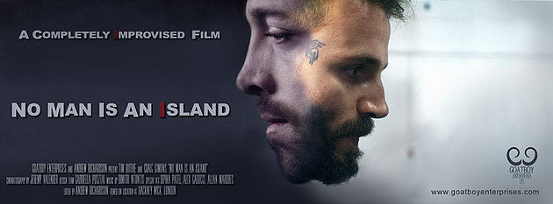

Sometimes we forget the true power of film. Film can take people to places or into situations that they will never see or experience. While this is all very well and good, we often over look the simplicity of human interaction and the magic that it can bring to the screen.

Director *Andrew Richardson* takes the idea of improvisation on film to a whole new level with his short ***No man is an Island***. He isolated his two leading actors from each other for four months. Then he worked with them individually to develop their characters and their story.

Shot in a warehouse, we see our two characters hide out together after committing a crime. Both in the film and in real life, they have never met before then. They try to understand why they have been chosen to work together for their mutual boss.

The isolation that *Richardson* forced on his actors leading up to the shoot allows for an explosive performance on screen. Each character is the complete opposite of the other. Raven played by *Tim Duthie* is an excitable man, full of negative energy and rage. His newly found counterpart, Mr. Doyle, played by *Craig Simons* is reserved and quiet. Mr. Doyle is unbothered by Raven’s insane ramblings.

As these two try to decide why they have been put together, they discover a darker reason for their paring.

The storyline is not that interesting, but when you remember that the entire film is improvised, shot in one take with only two cameras, we see this short differently. We see the power of interaction as these actors work off each other. They were told no final ending or plot points, just the freedom to explore their character, the other actor's character, as well as the scenario that they have been given.

A truly enjoyable watch from start to finish, ***No Man is an Island*** is gripping as well as smart, two thumbs way up Richardson.

**II.**

**Walk**

**Directed by David Rock**

**Animated Film Review by Chris Olson (**Edited from the original**)**

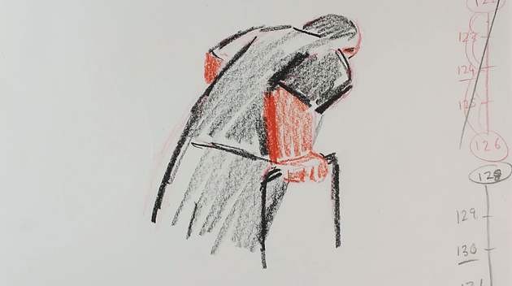

The craft of animation is a painstaking process. The demanding nature of making an animated movie often gets a great deal of respect from audiences, who at the very least will appreciate the effort that has gone into the shooting. Now...add this difficult filmmaking process in with a harrowing subject matter like physical disability, and you will find one particularly amazing short film: ***Walk***.

Directed and lovingly crafted by *David Rock*, this short recently won top prize at the **Independent Directions Film Festival** and rightly so. It portrays the efforts of one man attempting to walk with the aid of a Zimmer frame (walker). The inner turmoil that he feels is portrayed using abstract sounds and chaotic images. The animation aesthetic uses crayon drawing which has a magnificent effect. It simplifies what is a very complex issue without ignoring the importance of it. The flip book structure feels like a nightmarish look into a person's innermost fears.

The length could prove to be a drawback with audiences who may feel *Rock* could have developed the movie further. However, ***Walk*** successfully makes an emotional point about physical disability in a short amount of time. An aspect of the aesthetic which some viewers may find distracting is the jumbled numbers that appear down the side of the frame. Regardless, it cannot be argued that this is not a marvelous piece of filmmaking mastery.

**III.**

**Clutter**

**Directed by James Browning**

**Starring Stephen Chance, Sidney Keane, Helena Misciosia**

**Short Film Review by Evie Brudenall**

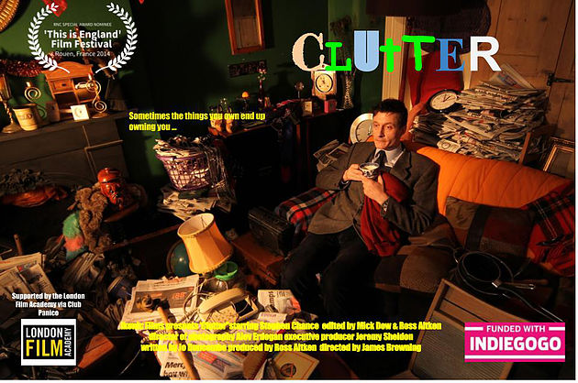

Have you ever wondered what compels people to hoard their belongings? Director *James Browning* and the team behind ***Clutter*** attempt to shine a light on such a question.

Nigel (*Stephen Chance*) is a man who spends most of his day sitting amongst the clutter that litters his house. He goes outside only to buy some plastic Tupperware from the market. He’s in trouble with debt collectors and does not accept help from his concerned friends and neighbors.

The character of Nigel is developed no further than that of a stereotypical introvert. His social skills are lacking, and he rarely leaves the safety and mess of his own home. However, his nice clothes and thoughtfulness to take plastic bags with him to do his shopping suggest he’s also organized and confident. The heaps of clutter that lie behind his front door paint a different picture altogether. The debt collectors who pay Nigel a visit also don’t escape the archetypal treatment. They’re aggressive and rude without any sympathy, whose seemingly only purpose is to make the audience feel sympathy for Nigel.

Nigel’s trips to the market to purchase containers show the audience that Nigel has people in his life who care about him, such as the Market Trader (*Sidney Keane*). Nigel adds the containers to his impressively large collection, but the reason behind the project remains unclear. The film’s focus on Nigel being a hoarder is equally as underdeveloped; we have no idea whether Nigel is attached to all of his belongings. As a result, it stunts his growth as a character.

***Clutter*** does succeed with natural performances from its actors, particularly *Stephen Chance* who delivers great understanding of his character’s social anxiety and tendency to avoid his problems rather than confront them. Brown also succeeds in filming in a unique way – tilted angles and close-ups help to make ***Clutter*** feel big despite its small scale.

Although the premise has a lot of promise that ***Clutter*** cannot achieve, it is supported by strong performances and an ambitious approach to filming the story.

**IV.**

**Loo**

**Directed by Stanislava Buevich**

**Starring Tallulah Sheffield, William Ludwig, John Bulleid, and Tamarin McGinley**

**Short Film Review by Evie Brudenall (**Edited from the original**)**



***Loo***. A horrifyingly dark and funny two and a half minute short from the mind of ***Stanislava Buevich*** – a new filmmaker with a unique and strange vision.

A date should be filled with many things, such as romantic moments, candle light, and delicious food. However, a date should not include wondering whether or not your partner will return from their trip to the toilet.

The attractive couple flirt with one another and most likely they will have a second date. Perhaps even the development of a relationship is possible. The unnamed woman (***Tallulah Sheffield***) excuses herself from the table to use the bathroom. In the bathroom an intensely upset woman sits in the next stall. Sheffield’s performance and reactions to the hysterical woman are wonderfully comedic and naturalistic. She can’t help but quietly laugh at the dramatic crying but still shows curious concern.

However, as the woman’s sobbing ceases, Sheffield’s character goes to investigate and finds the toilet overflowing with water – but the bathroom stall is empty. She leaves the white-tiled bathroom and returns to the dining area which has a warm and mood-lit scene thanks to the perfect lighting design and cinematography.

Shocking and bizarre, ***Loo*** has an ending that is both satisfying and repulsive in equal measure. It’s short, but definitely not sweet.